

In memory of

**Kathy Chester**

# This is the twenty-seventh annual seminar series sponsored through the Kathy Chester Memorial Endowment Fund. As a Riverside Speech Pathologist, Kathy was a strong advocate for continuing education and these seminars are a tribute to Kathy and her contribution to our field.

# The Twenty-Seventh Annual

Kathy Chester

# Memorial Seminar Series

***“Unmasking Facial Paralysis: An Interdisciplinary Approach to Diagnosis and Treatment”***

Shana McGrath MA, CCC-SLP and Kevin Quinn MD

Wednesday, June 11, 2025

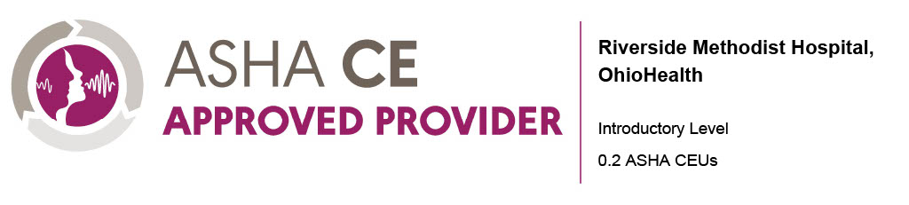

## Seminar Description

Facial paralysis presents unique challenges that can affect not only physical function, but also emotional well-being, communication, and participation in social interactions. This session will explore facial anatomy and physiology, the functional and psychosocial consequences of facial paralysis, and evidence-based assessment and intervention strategies. Additionally, we will discuss available treatment options, including therapeutic approaches, surgical and nonsurgical interventions, as well as the role of the multidisciplinary team (MDT) in case management.

## Speaker

Shana McGrath, MA, CCC-SLP is a speech language pathologist and evidence-based practice team lead at The Ohio State University Wexner Medical Center Outpatient Rehabilitation. Her work focuses on advancing quality improvement and implementation science within neurorehabilitation practice, with a particular emphasis on the psychosocial aspects of care and the management of peripheral facial nerve paralysis.

Kevin Quinn, MD is a recently hired facial plastic and reconstructive surgeon at The Ohio State University Wexner Medical Center. His training at Mass Eye and Ear/Harvard Medical School with Dr. Tessa Hadlock focused heavily on both surgical and non-surgical management of facial paralysis and associated facial nerve disorders, a skillset he is excited to bring to the Columbus area.

**Financial Disclosures:**

* Receives a speaking fee from OhioHealth

**Non-Financial Disclosures**:

* Has no relevant non-financial relationships to report

## Learner Objectives

After completion of this activity, participants will be able to:

1. Describe the anatomy and function of the face.
2. Identify key causes of facial palsy and their impact on facial function and patient well-being.
3. Conduct a basic assessment of facial function and recognize early therapeutic intervention strategies.
4. Explain available interventions for facial palsy, including therapy, surgical, and nonsurgical options.
5. Determine when and how to refer patients for specialist multidisciplinary management.

## Seminar Schedule

7:30-8:00 Introduction to Facial Anatomy and Physiology

8:00-8:30 Causes of Facial Paralysis and Impact on Function

8:30-9:00 Assessment of Facial Function

9:00-9:30 Interventions and Multidisciplinary Team (MDT) Management

## Location

Virtual or In-Person

OhioHealth McConnell Health Center

3773 Olentangy River Road

Lower Level, Rooms A & B

Columbus, OH

**For more information or questions, contact:**

Rehab Education

Email: [RehabEducation@ohiohealth.com](mailto:RehabEducation@ohiohealth.com)

## Registration

Register online at:

<https://ohiohealth.cloud-cme.com/Unmasking-Facial-Paralysis>

**$50.00**